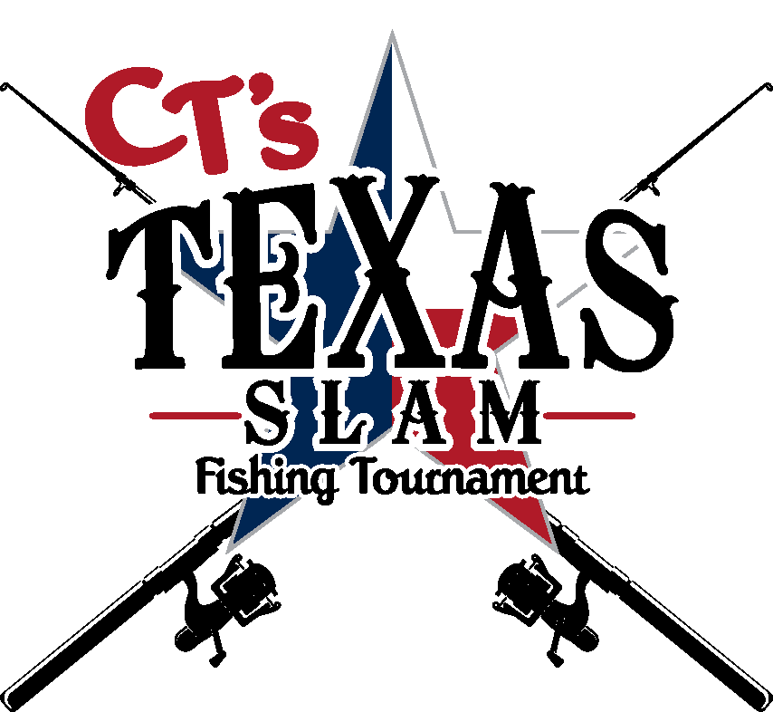

October 10, 2020
Steve’s Landing Bolivar Peninsula

Committee
Angela Baker
Gale Daigle
Gil Acosta
Kim Coutee
Renee Hebert
Amanda Lindoefer
Bernadette Loweree
Abby Mudd
Theresa Nolan
Laurie Smith
Cathy Taylor
Tyler Thomas
Robin Troy
Keene Wilson
Taylor Zummo

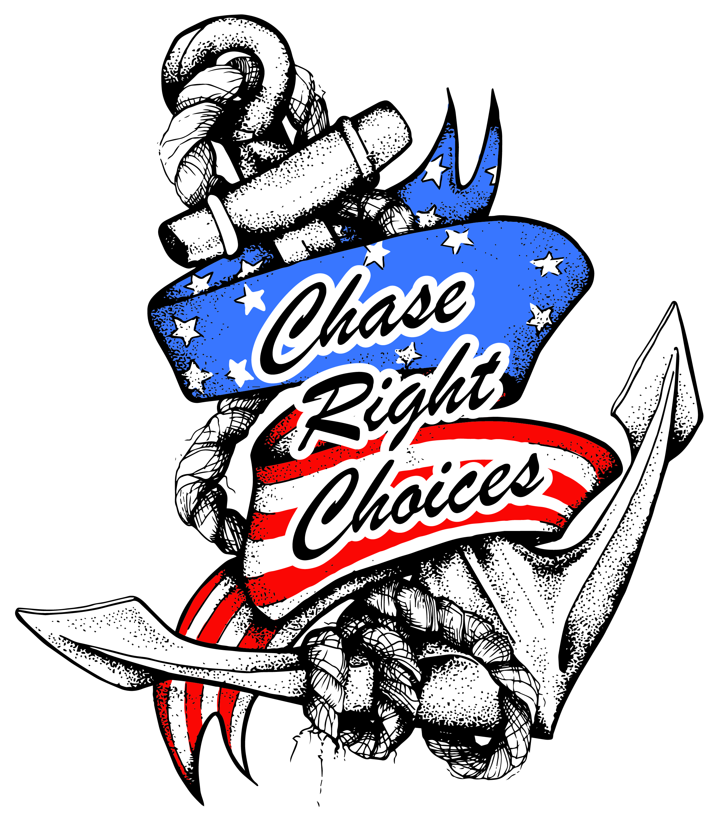

We are excited to share with you these sponsorships opportunities of the 3rd Annual CT’s Texas Slam Fishing Tournament this fall. The 1st Slam was a great success with tremendous support. There were many fishing teams and boats as well as hundreds of people to enjoy the day of food, fun, fellowship, games, silent auction and live music. Our 2nd Slam saw an amazing increase in teams, sponsors and astonishing support from the community. Our committee is working diligently to make this 3rd commemorative year, the most successful Slam to date.xecutive Committee and many
Below you will find sponsorship information. We hope you will find a level that fits your needs. If you don’t see something that you are interested in, we are happy to customize a sponsorship for you and your organization
If you have any questions or need additional information, please contact Cathy Taylor 409-656-9321

Flag Sponsor: $5,000 (Title Sponsor - Exclusive)
• Naming Rights to tournament
• Title sponsor recognition on all tournament materials
• Logo on all promotional materials & advertising
• Three complimentary fishing teams (1-team up to 4 people)
• Logo on tournament caps and t-shirts
• Prime placement for your company banner at event
• Name on Sponsor Sign
Star Sponsor: $2,500
• Logo or identification on promotional materials
• Two complimentary fishing teams (1-team up to 4 people)
• Logo on tournament t-shirts
• Your company banner placed at event
• Name on Sponsor Sign
Stripes: $1,500
• Logo or identification on flyer, website and social media
• One complimentary fishing team (1-team up to 4 people)
• Logo on Sponsor Sign
• Logo on tournament t-shirts
Red, White & Blue Sponsor $500
• Name on Sponsor Sign
• One complimentary fishing team (1-team 2 people)

Let’s make ripples together
Chase Right Choices is a 501-C (3) Non -Profit # 82-541363
Empowering people to make choices that will have a positive impact on their lives.
Proceeds from CT’s Texas Slam will be re-invested through local scholarships, outreaches and underwrites the” Seabatical of Hope,” retreats for mothers who have endured the loss of a child.

www.ChaseRightChoices.org
email:ct@chaserightchoices.org

